**M18**

**

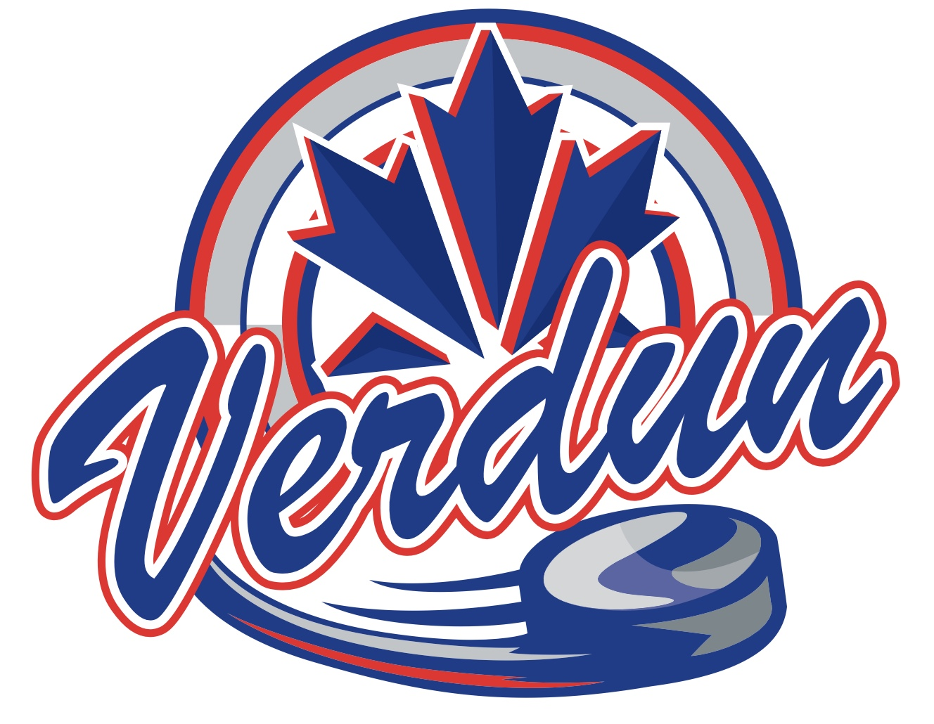



* Hayden Lépine
* Maxime Lu
* Théo Lecavalier
* Nolan Larin
* Félix Turcotte-Bédard
* Thomas Imena-Joncas
* Colin Wilson
* Julien Blein
* Benjamin Arsenault
* Olivier Gendron
* Raphael Khiati
* Samuel Morvan
* Robin Nadeau