**M18**

**

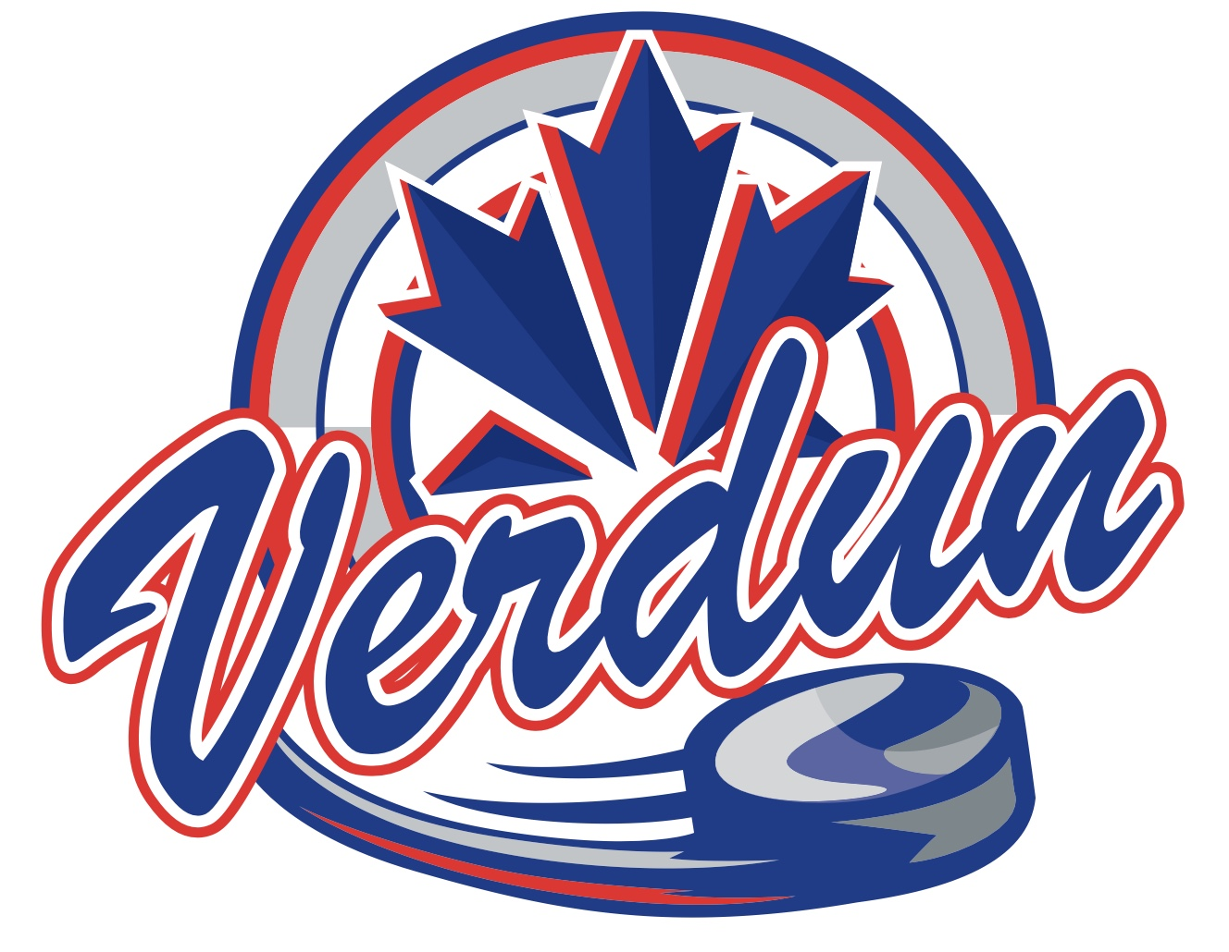



* Mathys Hébert
* Yoan Robert
* Samuel Robert
* Ludovic Giguère
* Alex Wu
* Eli Gascon
* Louis Sarasva Purcell
* Emile Boulerice
* Emersohn Campbell
* Elias Gonzalez-Legault
* Hans Zhang
* Xavier Giguère
* Sam Chalifoux
* Samuel Rivard