**M15**

**

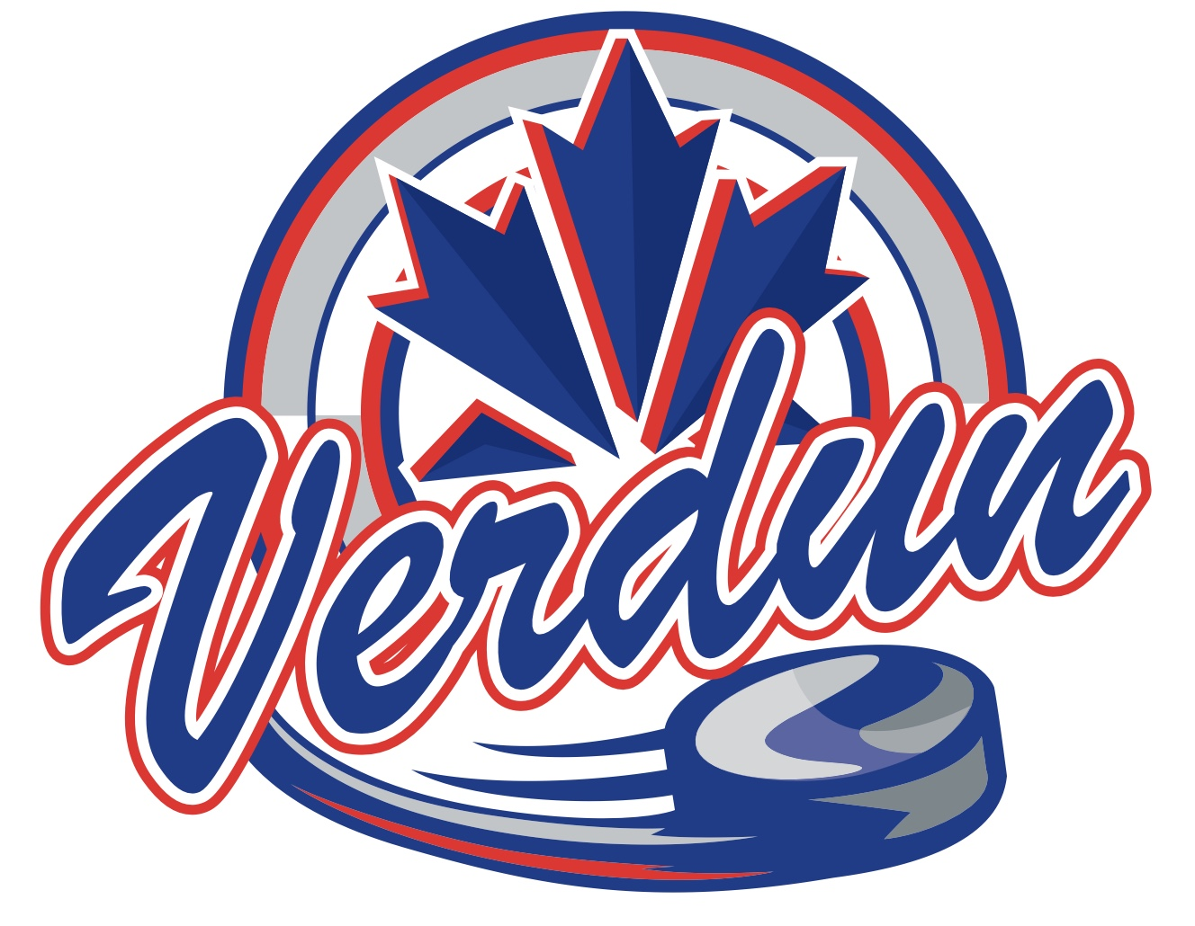



* Alexandre Hudon
* Keegan Cousins
* Djibril Turbide-Robles
* Spencer Chen
* Gustave Quentin
* Leif Campbell
* Benjamin Song
* Victor Perron
* Henri Michaud
* Erwan Durand
* Simon Caswell
* Erik Yusipov