**M15**

**

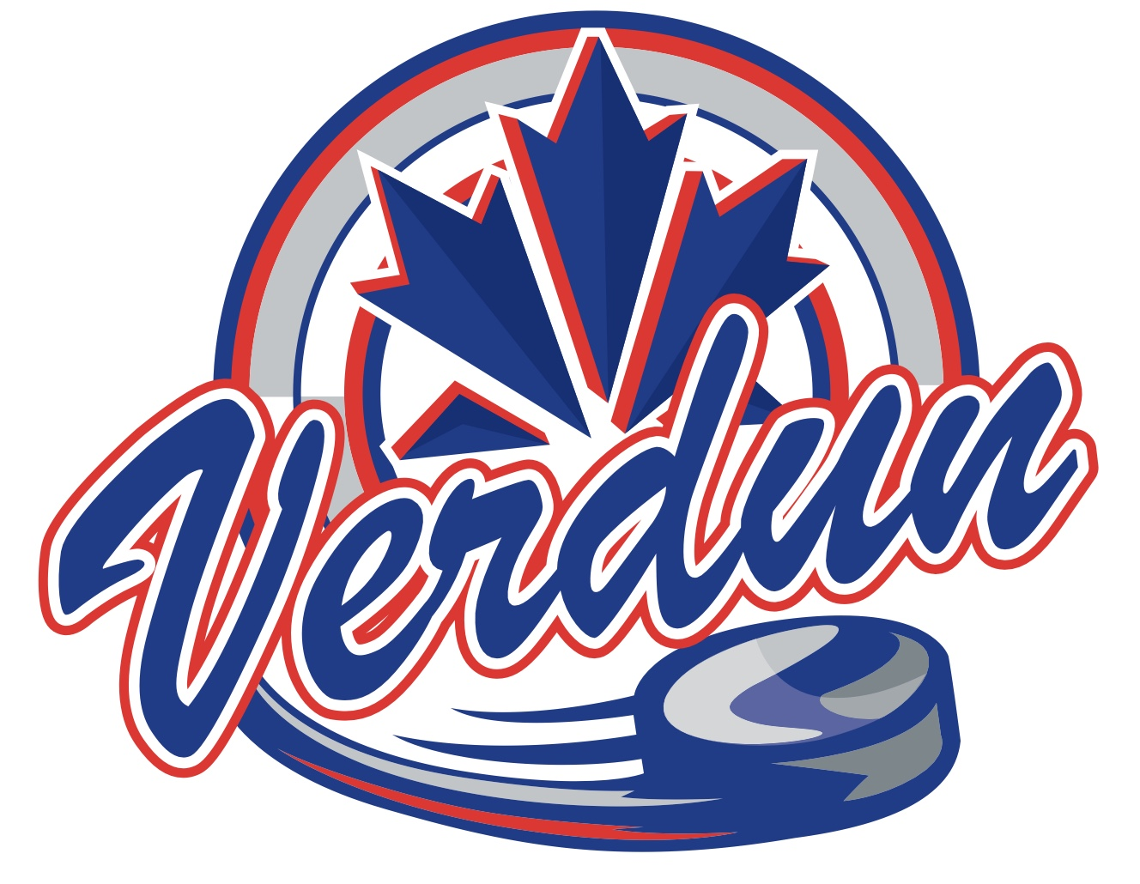



* Cayden Paiement
* Laurent Bourgeois
* Jules Cavanagh
* Thomas Jacques
* Jasmine Hervieux
* Lara Lagroy
* Gaspard Martin
* Mikaël Laberge
* Philippe Forget
* Samuel Morissette
* Nathen Oligny