**Junior**

**

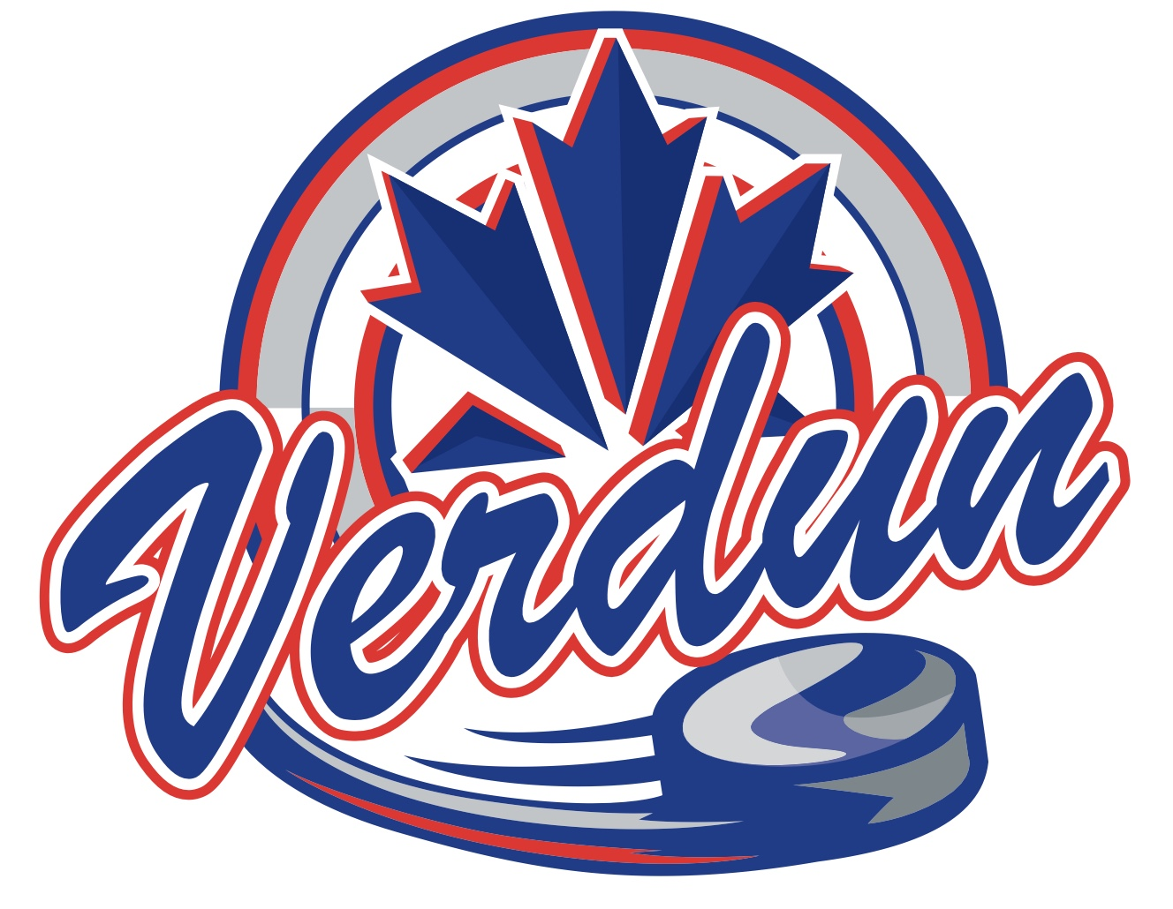



**À Venir**