**M13**

**

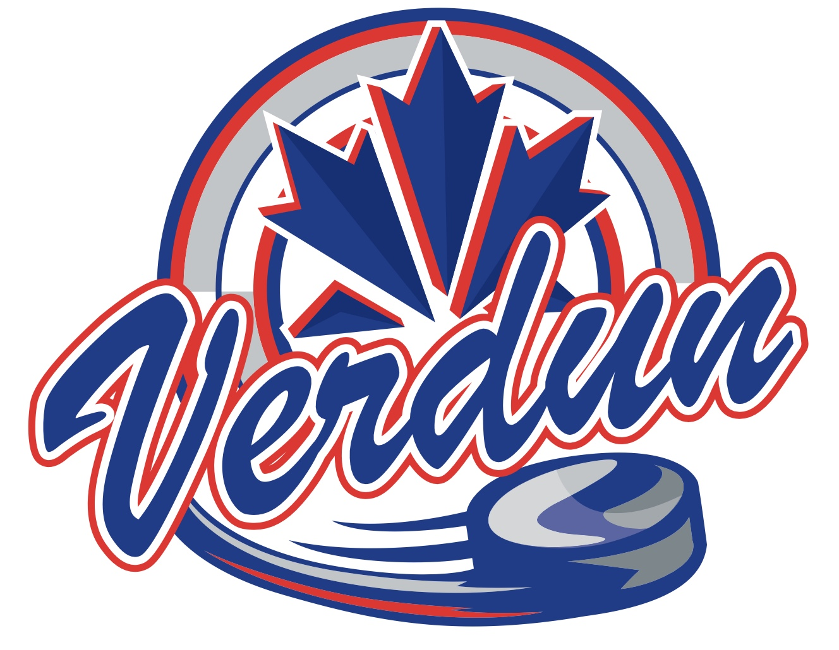



* Ethan Elliott
* Félix Jubelin
* Julien Proulx
* Cristoniel Poudrier
* Emeline Gagnon
* Julien Dominguez
* Ali Oualkacha
* Arthur Thomas
* Elliot Rodrigue-Borduas
* Isaac Dobey
* Adam Accad Wattar
* Marley Wilkinson